MAHABUB HOSSAIN
  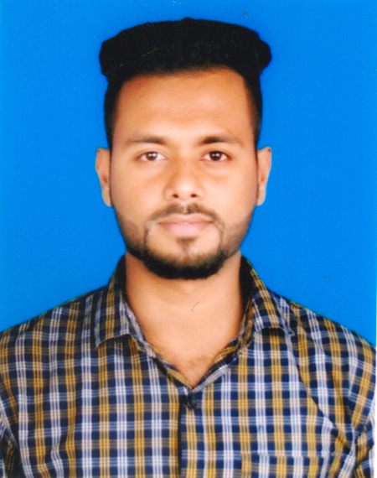
Address:1118/19,South Ibrahimpur, Dhaka cantt.dhaka-1206. Home Phone: 01778271440
Mobile : 01778271440,01680725909
e-mail : mahabub.hossain.5909@gmail.com

Career Objective:
Looking for a challenging growth oriented position for professional experience and willing to work in an environment where there is an opportunity of self-assessment and self-improvement in both individual and team based work that will ultimate help

Career Summary:
An innovative and ambitious graduate skilled in Marketing and Audit Of sell’s, System Analysis & Designing, Analyzing and Testing of Marketing stratigie’s and Directive’s for Multinational, industrial and other applications. Knowledge of information Techonology techniques and computer aided software management methodologies.

Special Qualification:

- MS Word (Fluently proficiency in Bangla & English Typing)
- MS Access (Doing all Vendors Seles Repot, Top Shite & Cash Collection input their)
- Internet ( Browsing Internet is so Good Like gmail, Internet Explorer, Mozila, & Many thing)

Employment History:
Total Year of Experience : 6 Year(s)

1.Modern Trade Officer (4 year and still continue)
Himalaya Drughs Ltd.
Duties and Responsibilites: )
- Supervise daily sales and Trade marketing Activites
- Maintain administrative activities.
- Increase wonderful trade relation with different traders and customers.
- Monitor market Trends, research consumer market,and competitors activities.
- Facevook and social media activities.
- Forecast Market Demand and achieve sales Target.
- Vendor acquisition.
- Vendor maintain focus sales.
- Ensure sustainable growth of own market share in market
2. Direct Sales Executive (1 year)
PNG Group
Duties and Responsibilites:
- Supervise daily sales and Trade marketing Activites
- Maintain administrative activities.
- Increase wonderful trade relation with different traders and customers.
3. Merchendiser
Tradeswoth LTD. (1 year)
Duties and Responsibilites:
1.Supervise daily sales and Trade marketing Activites
2.Maintain administrative activities.
3.Increase wonderful trade relation with different traders and customers.

Academic Qualification:
Exam Title | Concentration/Major | Institute | Result | Pas.Year | Duration | Achievement
B.B.A (Hons) | Accounting | Mirpur University College | CGPA:2.55  out of 4 | 2017-2018 | 4 years | -
H.S.C | Business Studies | BAF Shaheen College. | CGPA:4.40  out of 5 | 2013 | 2 years | -
S.S.C | Business Studies | Muslim Modern Academy | CGPA:4.69  out of 5 | 2011 | 2 years | Passing exam with First class.

Career and Application Information:
Looking For | : | Mid Level Job
Available For | : | Full Time
Preferred Job Category | : | Marketing and Sales ,Brand Promotion,Education/Training, Telecommunication ,Multinatioal Group,Financial Organization,Insurance Company Etc.
Preferred District | : | Anywhere in Bangladesh.
Preferred Organization Types | : | Marketing And Sales ,Branding Institution, Financial Enabled Service, Shipping, Mobile Accessories, Insurance,Bank.

Specialization:
Fields of Specialization | Description
- Using Microsoft Office software Like Word,Excell,Powerpoint truly affectively.  - Using Adobe software and making Online Ad’s Through Photoshop and Illustrator. | • Entry the whole audit and financial report through Tally software.  Making financial statement through different customer needs.

Extra Curricular Activities:
Journalism in STAR CAMPUS magazine, a weekly magazine of the daily star, national newspaper. Photography (Some Photograph published in a weekly magazine of the daily star). HOBBY: Sports, listening music, reading technical article etc.

Language Proficiency:
Language | Reading | Writing | Speaking
Bengali | High | High | High
English | High | High | High

Personal Details :
Father's Name | : | Kamrur Hossain
Mother's Name | : | Rahima Akhter
Date of Birth | : | June 24-1996
Gender | : | Male
Marital Status | : | Unmarrid
Nationality | : | Bangladeshi
National Id No. | : | 19962650898000097
Religion | : | Islam
Permanent Address | : | Vill:Sonapur, P.O:Fakirhat,P.S:Feni Zill: Feni.
Current Location | : | Dhaka

I hereby declared that all the information above are given in this resume are true and correct to the best of my knowledge.

Yours Faithfully,

---------------------------------
Signature & Date

